***Personal Portfolio Website***

**Submitted by-**

1. **Tiya Arora**

**2460467**

[**Tiya.arora@btech.christuniversity.in**](mailto:Tiya.arora@btech.christuniversity.in)

1. **Megha Sherino**

**2460406**

[**megha.sherino@btech.christuniversity.in**](mailto:megha.sherino@btech.christuniversity.in)

1. **Sanjana.N.Kothwal**

**2460443**

[**sanjana.n@btech.christuniversity.in**](mailto:sanjana.n@btech.christuniversity.in)

**Course: UI/UX Frontend**

**Instructor Name: Ms. Nagaveena**

**Institution: Christ University (kengeri campus)**

**Date of Submission: 13/08/2025**

**Project Summary**

This project involved the design and development of a fully responsive personal portfolio website, built exclusively using HTML5 and CSS3. The portfolio serves as a professional digital presence, aimed at showcasing the user’s skills, work experience, completed projects, resume, and contact details in a clean, accessible, and visually appealing manner. The primary objective was to create a website that adheres to modern UI/UX design principles while maintaining optimal performance and compatibility across various devices, including desktops, tablets, and smartphones. The development process prioritized semantic HTML5 structuring for improved accessibility and SEO, as well as organized CSS3 styling to achieve consistent branding, layout control, and responsive behavior. The final product is a polished, user-friendly, and lightweight website that not only enhances personal branding but also acts as a powerful tool for career growth, client acquisition, and networking opportunities.

**Objectives**

The key objectives of the project were as follows:

1. **Design a User-Friendly Interface:** Create an intuitive layout with a focus on visual hierarchy and modern UI design principles to ensure a seamless browsing experience.
2. **Responsive Web Design:** Develop a layout that adjusts flawlessly to various screen sizes and devices, ensuring consistent functionality and readability.
3. **Semantic HTML5 Implementation:** Utilize structured and meaningful HTML5 tags for better content organization, SEO optimization, and accessibility compliance.
4. **CSS3 Styling for Branding and Layout:** Apply CSS3 techniques for color schemes, typography, spacing, and alignment, ensuring cohesive branding throughout the site.
5. **Cross-Device Accessibility:** Guarantee that the website maintains usability and aesthetic integrity across desktop, tablet, and mobile platforms.

**Scope of the Project**

The scope of the project was intentionally limited to front-end development using only HTML5 and CSS3, without the inclusion of JavaScript or server-side technologies. This approach ensured simplicity, speed, and a strong focus on design principles. The website was designed to support desktop, tablet, and mobile viewports through the use of responsive design techniques such as media queries and flexible layouts. The content was organized into dedicated sections including:

* **About** – An overview of the individual’s background, skills, and expertise.
* **Projects** – A curated showcase of past work with descriptions.
* **Resume** – A structured summary of education, work experience, and qualifications.
* **Contact** – A section containing communication details and a basic contact form layout (non-functional due to no back-end).

| **Tool/Technology** | **Purpose** |
| --- | --- |
| **HTML5** | Markup language for structuring and organizing website content using semantic tags |
| **CSS3** | Styling and layout management, including responsive design techniques |
| **Visual Studio Code (VS Code)** | Primary code editor for writing and managing project files |
| **Google Chrome DevTools** | Testing, debugging, and real-time design adjustments |

**HTML Structure Overview**

The HTML structure was built around semantic elements for better readability and SEO performance. Key tags used included <header>, <nav>, <main>, <section>, and <footer>. The website content was divided into reusable and clearly defined sections: About, Projects, Resume, and Contact. Navigation was implemented using an unordered list (<ul>) containing anchor links that allow smooth scrolling to different parts of the page.

**CSS Styling Strategy**

The styling was handled through a single external CSS file (style.css), organized with clear commenting and logical sectioning for maintainability. The layout leveraged **Flexbox** and **CSS Grid** for positioning and alignment, ensuring a visually consistent design. **Media queries** were used extensively to adapt the design for multiple screen sizes. The color palette, typography, and spacing were selected to reflect a professional yet approachable visual style, enhancing the site’s overall branding.

**Final Outcome and Usefulness**

The completed portfolio website meets all stated objectives, offering a clean, responsive, and professional platform for presenting personal and professional details. It serves as an effective self-marketing tool, improving visibility for job applications, freelance opportunities, and client outreach. By relying solely on HTML5 and CSS3, the site remains lightweight, fast-loading, and easy to maintain or expand in the future.

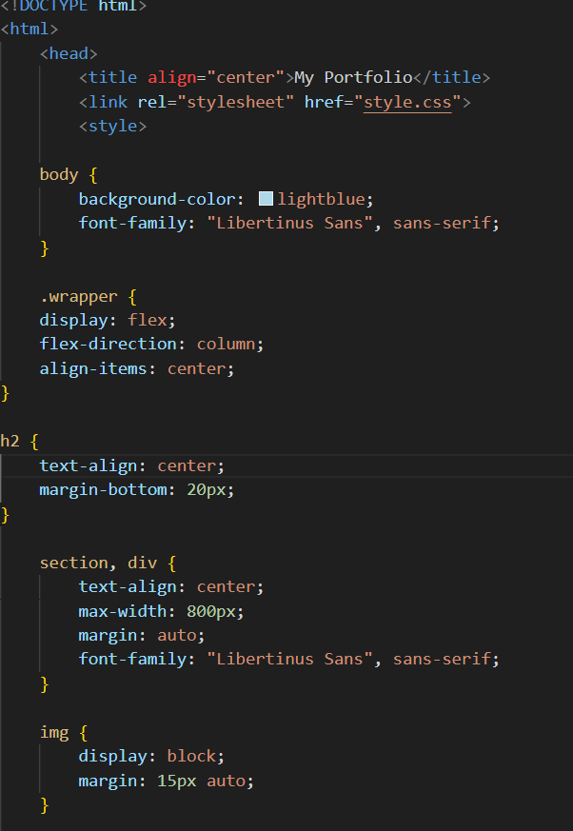

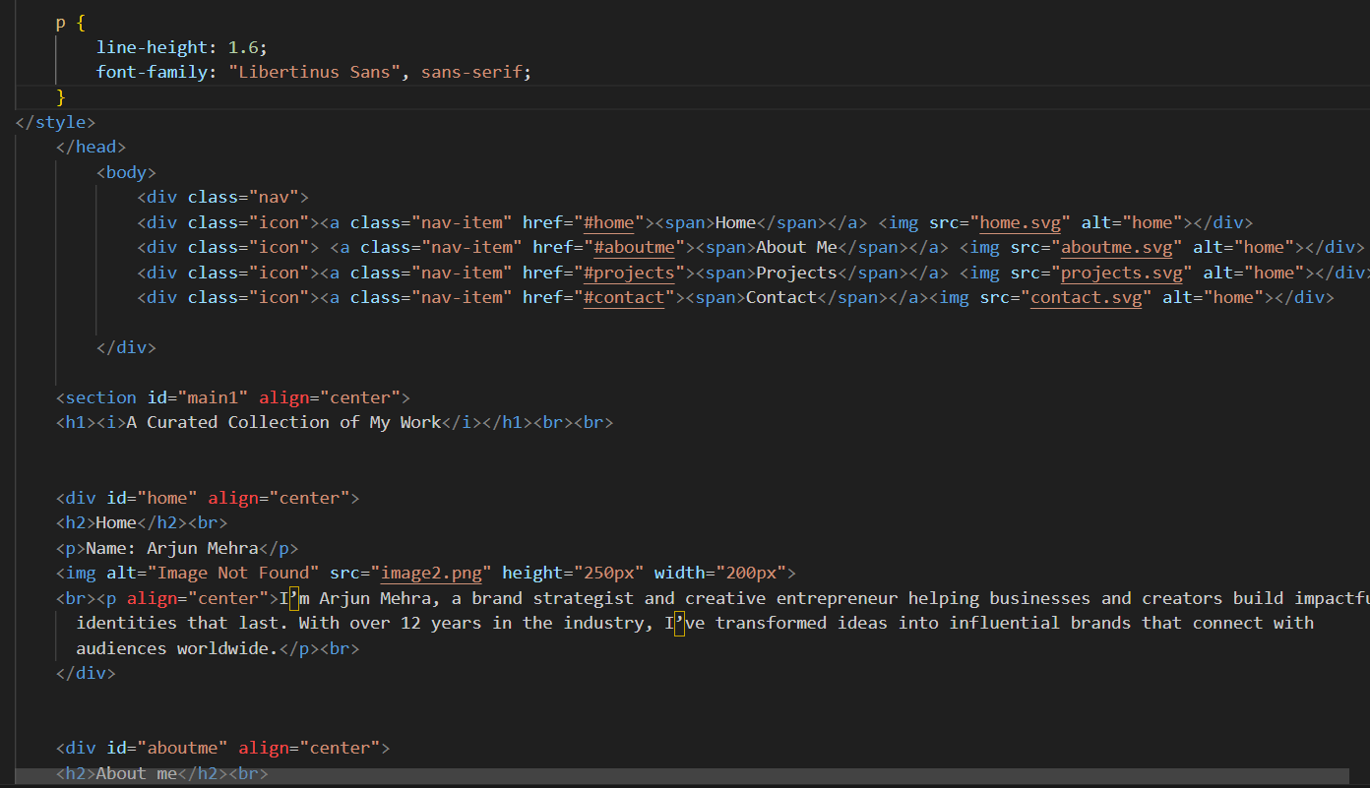

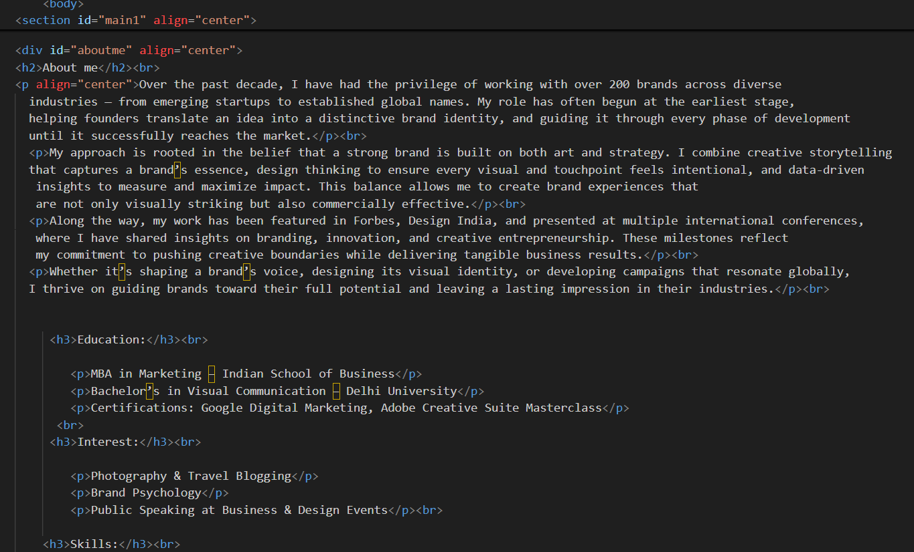

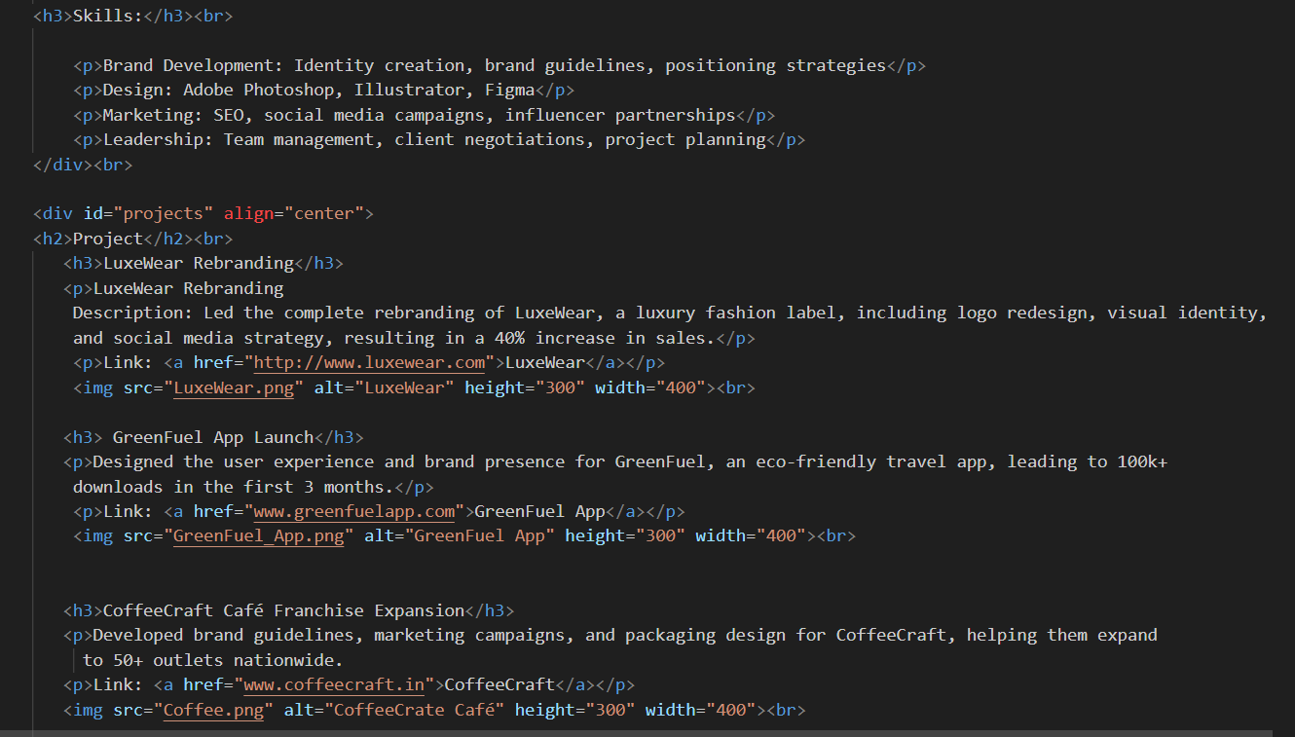

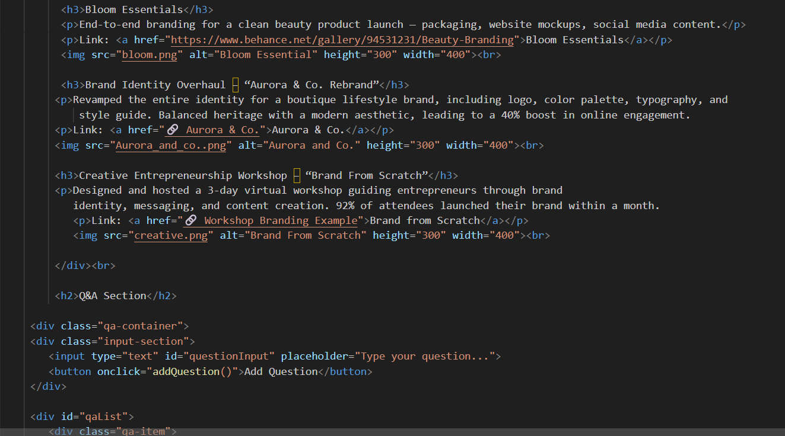

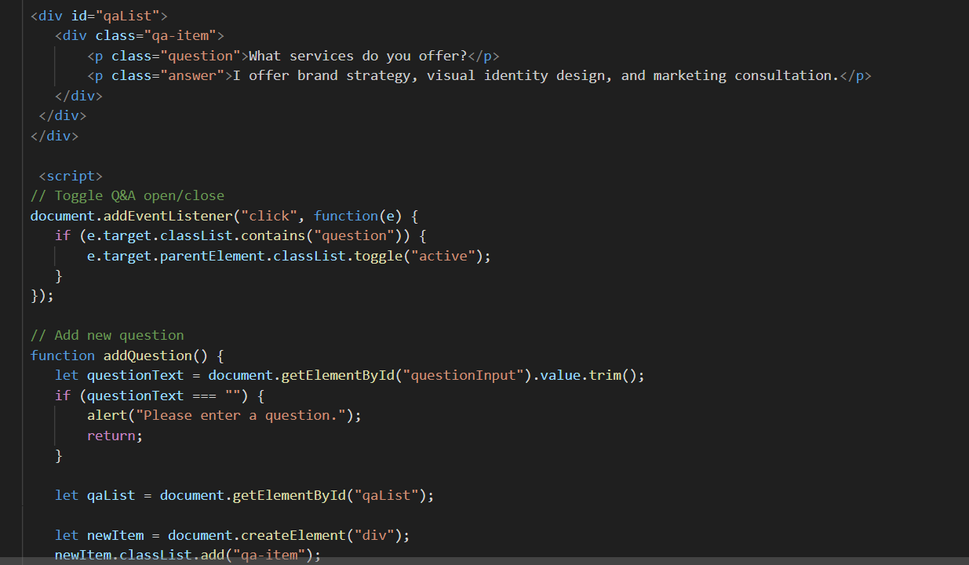

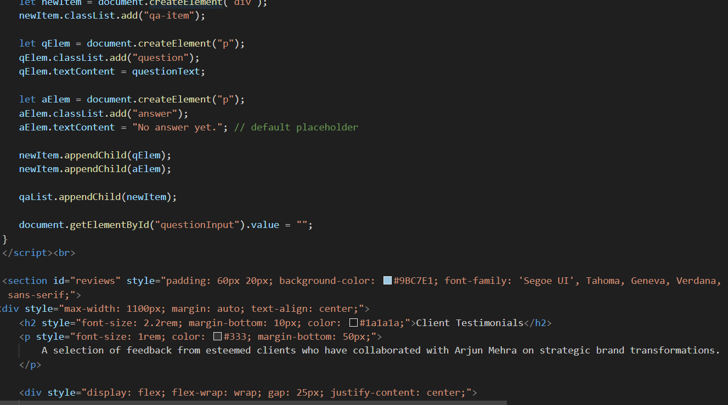

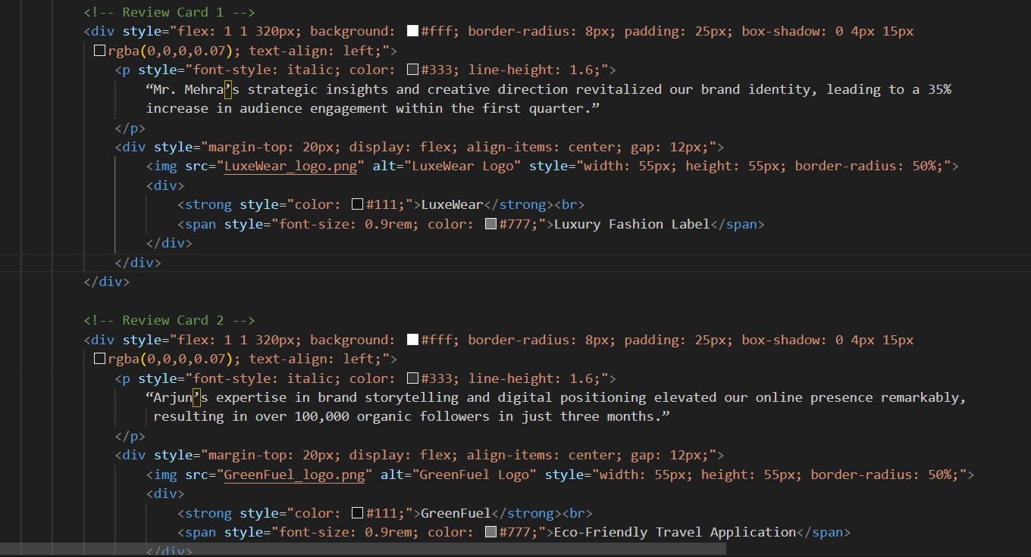

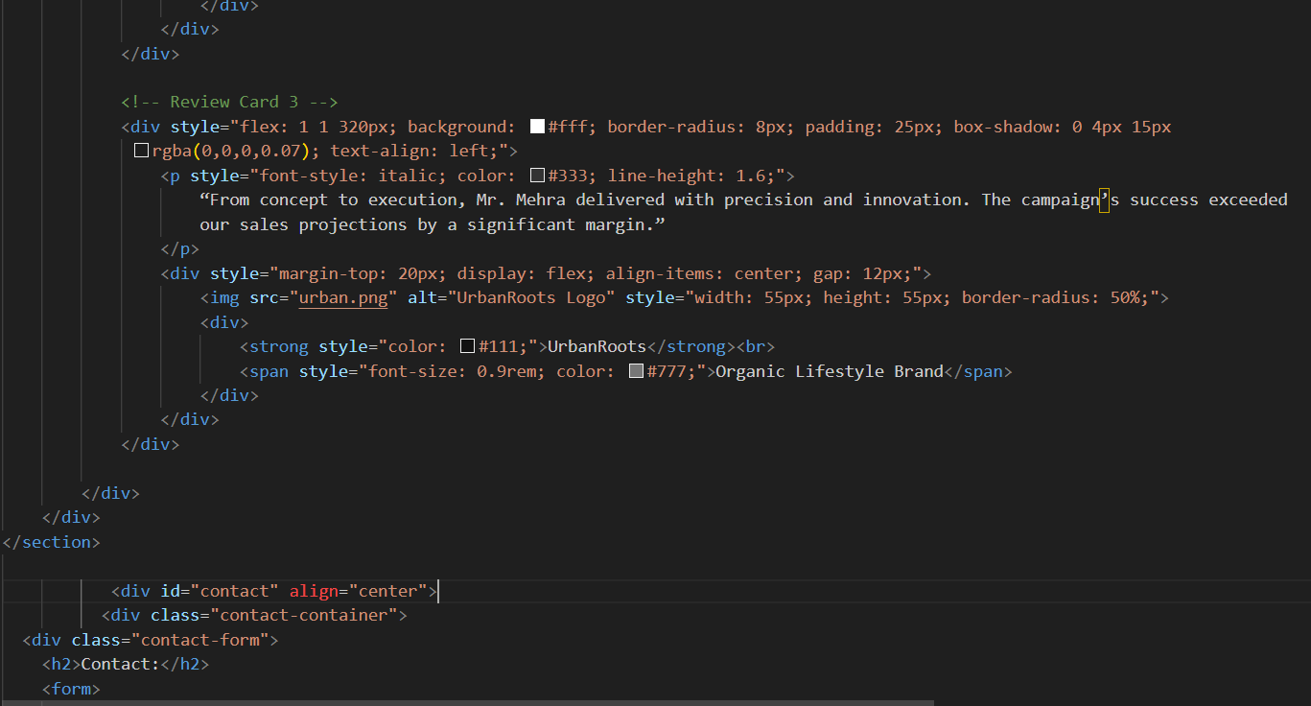

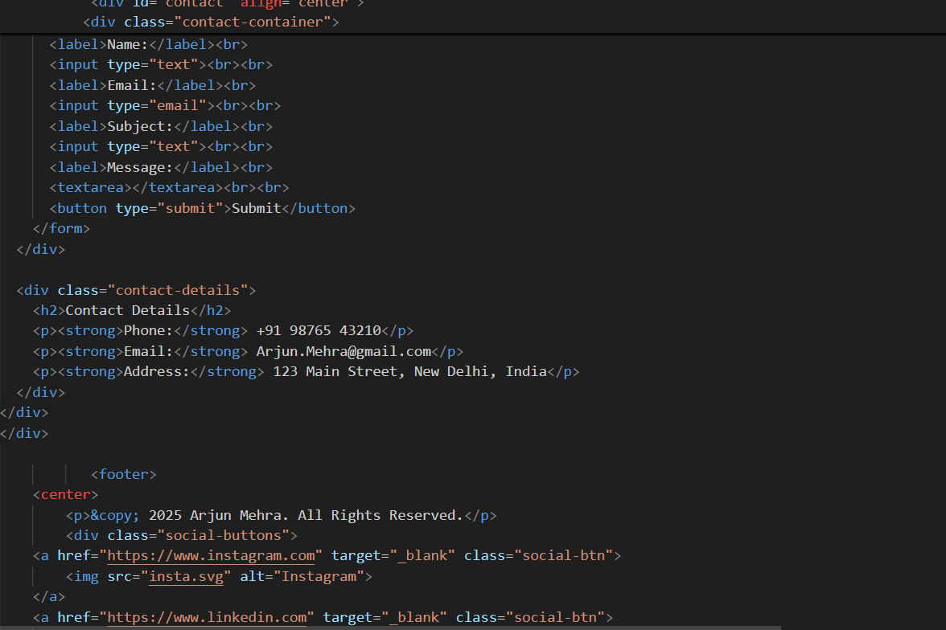

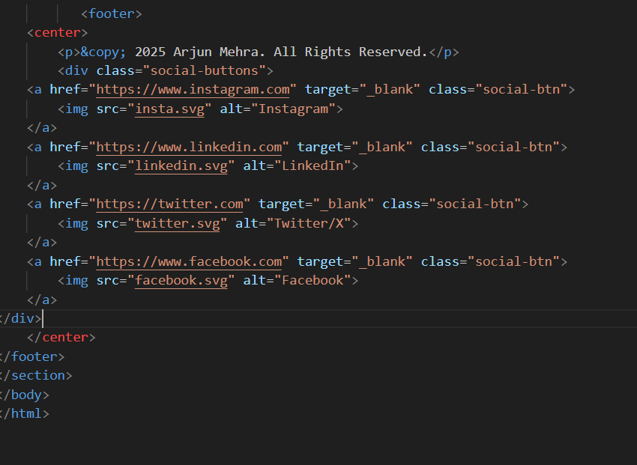

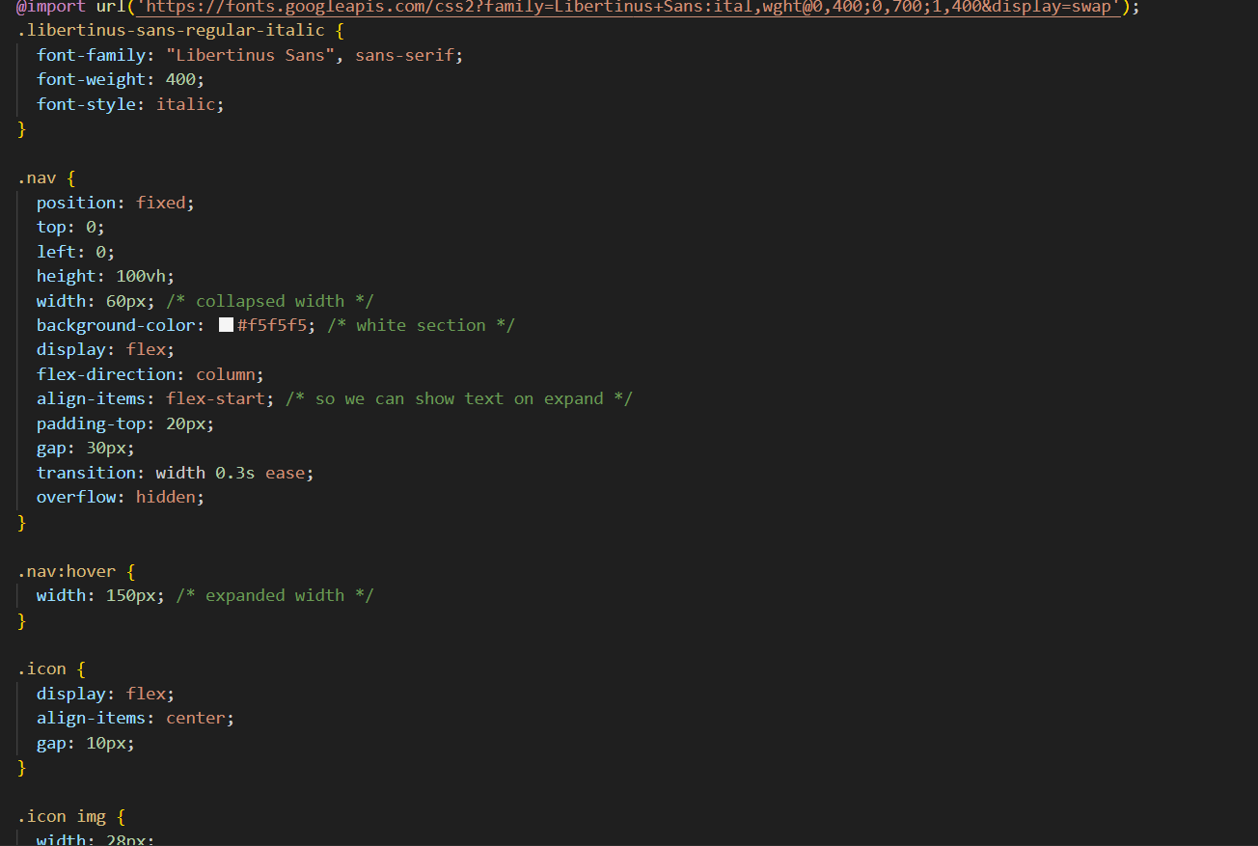

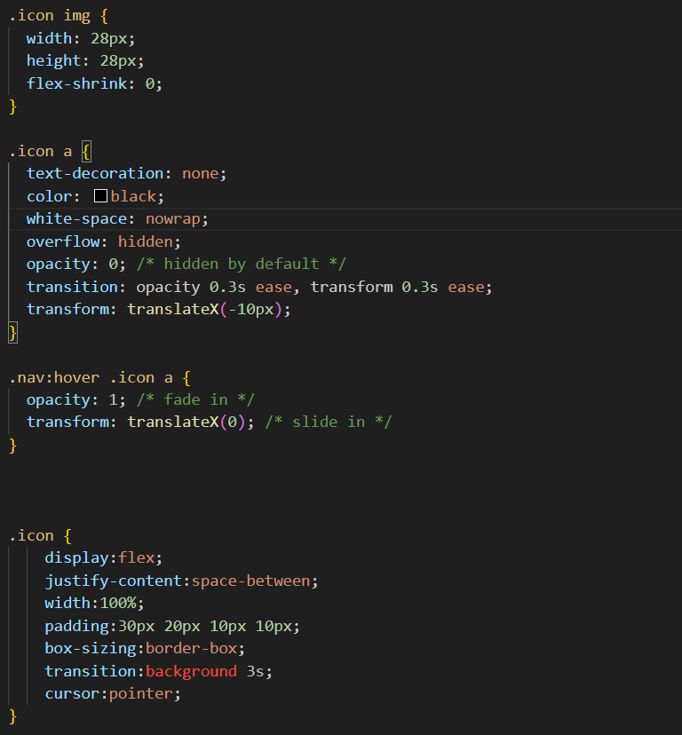

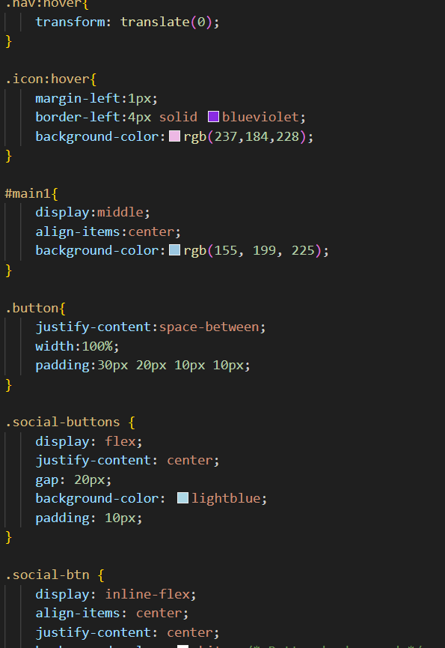

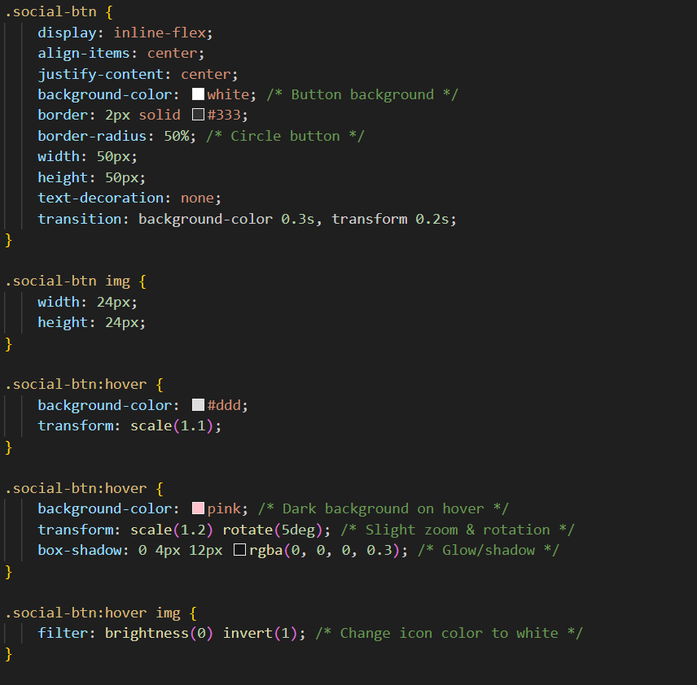

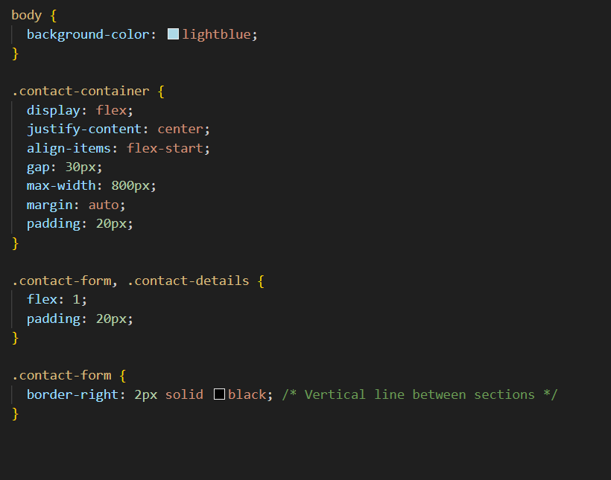

***Output:***

